**Neural Network for Logic Gates**

**Model Architecture**

**Dataset**

The dataset consists of input-output pairs for various logic gates (XOR, AND, OR, NOR, NAND). The function get_dataset generates the dataset for the specified logic gate. Each dataset includes four input pairs (representing all possible combinations of two binary inputs) and their corresponding outputs according to the logic gate's truth table.

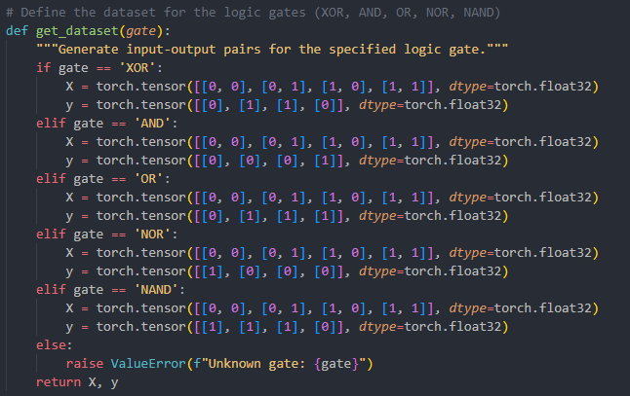

**Neural Network Model**

The neural network model is defined in the LogicGateNet class. It consists of:

1. **Input Layer**: Accepts two binary inputs.
2. **Hidden Layer**: A fully connected layer with a user-defined number of hidden units, followed by a ReLU activation function.
3. **Output Layer**: A fully connected layer with one output unit, followed by a Sigmoid activation function to produce an output in the range [0, 1], representing the probability of the output being 1.

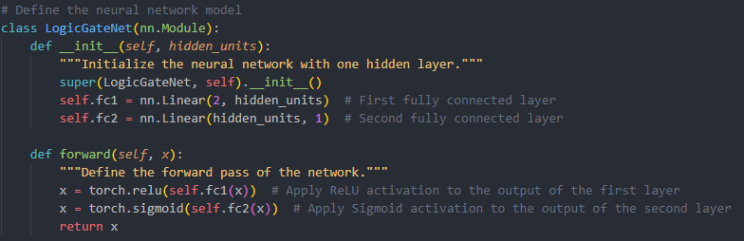

## Training Process

### Loss Function and Optimizer

The model is trained using the Binary Cross-Entropy Loss (nn.BCELoss), which is suitable for binary classification problems. The optimizer used is Adam (optim.Adam), which is an efficient variant of stochastic gradient descent.

### Training Loop

The train_model function handles the training process. The function takes the following parameters: gate (logic gate type), learning_rate, hidden_units, and epochs. During training, the model performs forward passes, computes the loss, performs backpropagation, and updates the model parameters using the optimizer. The training loop runs for the specified number of epochs.

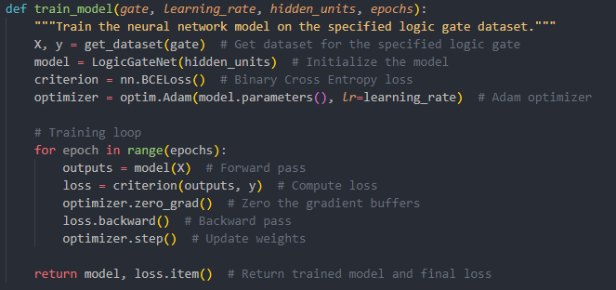

## Evaluation

The evaluate_model function evaluates the trained model on the specified logic gate dataset. It computes the model's accuracy and returns the accuracy and the predicted values.

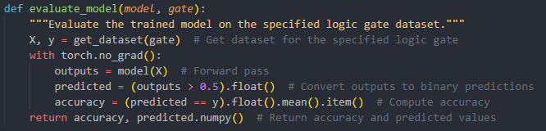

## Visualization

The plot_decision_boundary function visualizes the decision boundary of the trained model. It plots the decision boundary along with the original data points to show how well the model has learned to classify the inputs according to the logic gate's rules.

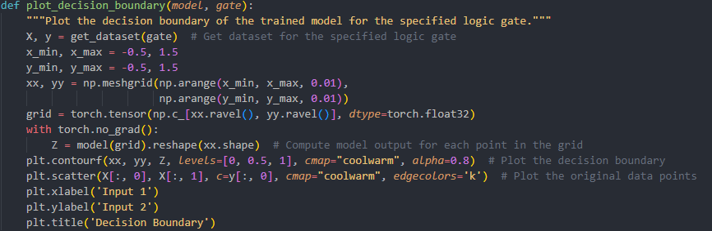

## Results

### Training and Evaluation

After training the model, the final loss and accuracy are displayed. The model's accuracy indicates how well it has learned to classify the input pairs according to the specified logic gate's rules.

### Prediction

The trained model can be used to predict the output for any given pair of binary inputs. The prediction is done by feeding the inputs to the model and thresholding the output at 0.5.

### Decision Boundary

The decision boundary plot visually represents the regions in the input space where the model predicts different outputs. This helps in understanding how well the model has generalized the logic gate's function.